**Summary of variables**

My response variable is ‘avgspeed’ - the average speed measured in miles per hour during a run.

My predictor variables are:

* ‘avghr’ – the average heart rate measured in beats per minute
  + As average heart rate increases, I expect average speed to decrease. A well-conditioned body will be faster.
* ‘maxhr’ – the maximum heart rate measured in beats per minute
  + As max heart rate increases, I expect average speed to decrease. The runner may be overexerting themselves if max heart rate is spiking, thus resulting in poor performance.
* ‘avgcadence’ – the average cadence measured in steps per minute
  + As average cadence increases, I expect average speed to increase. The Garmin coach reminds me after every run that if I can increase my cadence I should run more efficiently.
* ‘maxspeed’ – the maximum speed measured in miles per hour
  + As max speed increases, I expect average speed to decrease. Again, the runner may be overexerting themselves.
* ‘distance’ – the distance measured in miles
  + As distance increases, I expect average speed to decrease. The runner will need to adjust pace to be able to run further.

**The estimated regression equation:**

$$Y = .022 * avghr - .002 * maxhr + .047 * avgcadence + .025 * maxspeed – 0.103 * distance-3.904$$

**A table of the *t*-statistics, standard errors, and *p*-values in each of the tests**

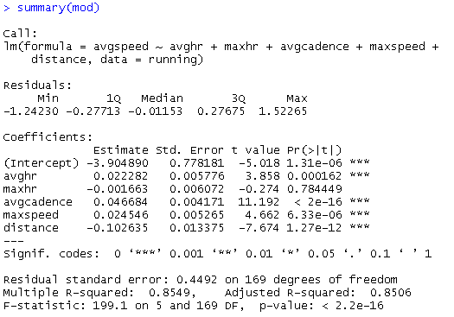

All predictors were found to be significant at the 0.05-significance level except maxhr.

**An interpretation of each of the regression coefficients which are found to be significant at a 0.05-significance level**

For every bpm the average heart rate increases, the average speed *increases* .022 miles per hour

For every bpm the max heart rate increases, the average speed decreases .002 miles per hour. Note that this variable wasn’t found to be significant at the 0.05- significance level, but I am including it here for completeness.

For every step per minute the average cadence increases, the average speed *increases* .047 miles per hour

For every mph the max speed increases, the average speed *increases* .025 miles per hour

****For every mile the distance increases, the average speed *decreases* .103 miles per hour

**The values of the F-statistic and associated *p*-value in the test of overall regression,**



**An accurate and descriptive interpretation of sigma hat (including units) and R2**

Sigma hat (0.4492) is the estimated standard deviation of the errors. It represents the leftover (residual) variation on the response variable after applying our model. Using our model to predict average speed results in an error of .4492 mph.

R2 is the coefficient of determination. It represents the proportion of observed variability which is explained by the linear model: 85.49% of the observed variability in average speed can be explained by the predictors used in the regression model.

**Other hypothesis tests performed**

a) I tested H0: avghr = maxhr = maxspeed = 0 against HA: not H0.

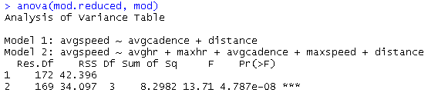

The p-value here is incredibly small, suggesting I reject H0 and stay with the full model. Perhaps I would have gotten a different result had I only tested maxhr = 0 (since it wasn’t found to be significant at the .05 percent level.

b) Next I looked at H0: βdistance (coefficient of distance)=-.5 against Ha: βdistance ≠-.5

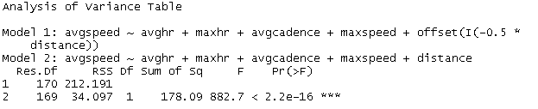

Again, I got an incredibly small p-value, suggesting I reject H0. Distance does have a negative impact on average speed, but it is not negative .5 miles per hour per extra mile ran.

c) Finally I looked at the claim H0: βavghr = βavgcadence | All other coefficients = 0

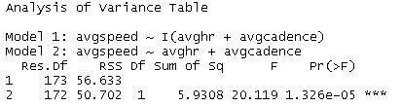

I analyzed this only because looking at the data, the values in avghr and avgcadence are typically very close to each other. Again, the p-value here is very close to 0, so I should reject H0.